Organice Publish

Rapport Type | Administration / Training document
Author: | Paul van de Sande
Date: | 23-5-2012
Version: | 1
Status: | Final
Number of Pages: | 21

Version | Date | Modified by | Description
1 | 23-05-2012 | Paul van de Sande | Initial Document

Table of Contents
Table of Contents 3
1 Introduction 4
2 Organice Publish servers 4
3 Organice Publish Process 5
4 Publish workflow 7
4.1 Publish Features 7
4.2 Create Publish AutoCAD drawing 8
4.3 Create Publish Office document 9
5 Publish Credentials 11
5.1 Job server 11
5.2 SharePoint server 12
6 Job Server, Job Launcher 13
7 Job Server, Document Processing Service (DPS) 15
7.1 Configuration 16
8 Debugging 17
8.1 User: Workflow status indication per document 17
8.2 Publish Queue 17
8.3 Smart Inspect 18
8.3.1 Publish steps 18
8.3.2 Freeze logging information 19
8.3.3 Search logging information / track a document 19
8.4 AutoCAD log 20

Introduction
This document describes the general Organice Publish process and administration settings to support this process. The document can be used by end-users and administrators.

For basic installation and configuration please use documents:
- Organice Publish Installation and Configuration Guide 2008 R2.pdf
- Organice.Publish Document Processing Service Configuration Guide 2008 R2.pdf
- Organice.Publish DPS Configuration Guide 2008R2 Upd1.pdf

Organice Publish servers
The next image describes the different servers relevant for the Organice Publish Process. The image can contain references to chapters containing detailed information.
The Source and Target servers can be the same SharePoint environment.

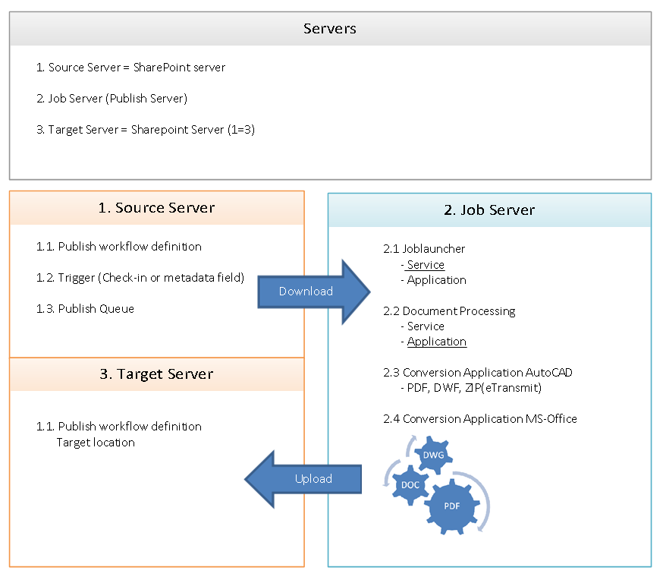
Picture 1Organice Publish Servers

Organice Publish Process
The next image describes the Organice Publish Process. It also contains references to actions or checks if the process fails. The image contains references to chapters containing detailed information.

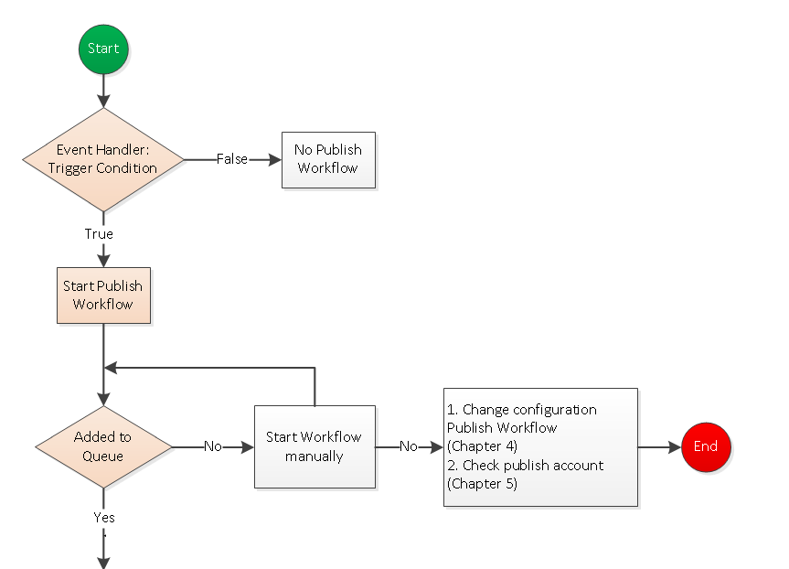
Picture 2 Publish Source server process
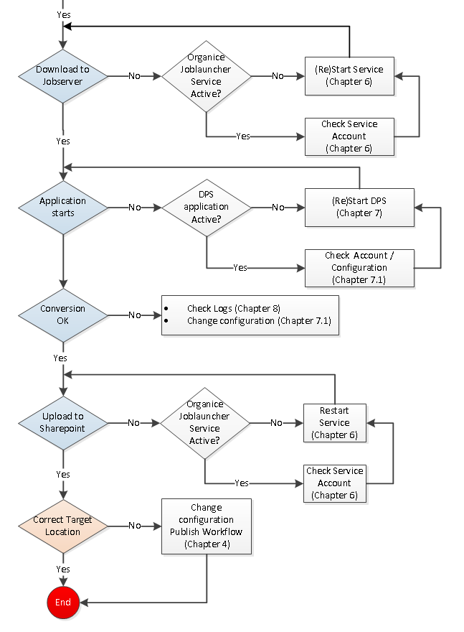
Picture 3 Publish Job server process

Publish workflow

Publish Features
Publish Workflows are depending on Site features and Site Collection features to be created and to start.

Open the Site Collection Features.

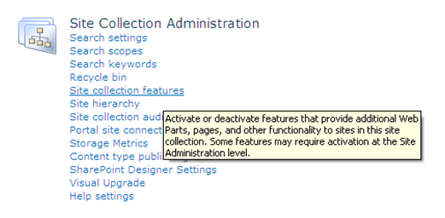

Check if the next Site Collection Features are active:
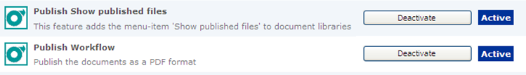

Open the Site feature.

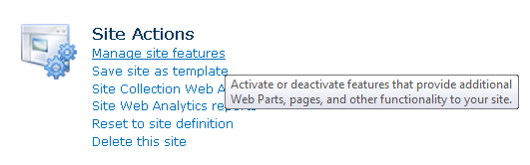

Check if the next Site feature is active:

Create Publish AutoCAD drawing
This documentation will show an example for publishing a CAD file (*.dwg).

- Open the correct SharePoint Site
- Select the correct SharePoint library
- Library Tools library Library Settings Workflow Settings Add a workflow
- Select a Workflow template: ‘Publish workflow’
- Type a unique name for this workflow: PublishCAD
- Select Next

Configuration:
- Trigger Workflow Settings options:
  - On a value of a specific metadata fields
  - When a minor version is created
  - Only when a major version is created

You can always start the workflow manually.

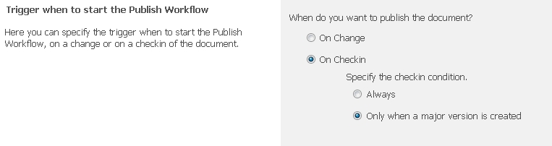

- Check ‘Convert the document’
- Define the target location, Publish library (Tip: copy & paste URL from Organice without ‘/Forms/AllItems.aspx’).
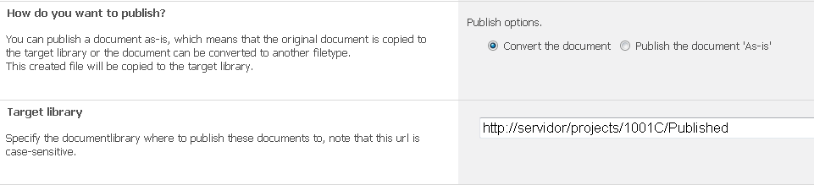

- Give a TAB to fill the mapped fields after entering the target document library. If the error message ‘Invalid library’ appears please check the authorisation (chapter 5).
- Set the file extension that should use this workflow: .dwg
- Define the script to use

ARPTemplate_Adobe_PDF_1PDF = Create 1 PDF from different layouts.
ARPTemplate_Adobe_PDF = Create multiple PDF’s, one per layout.
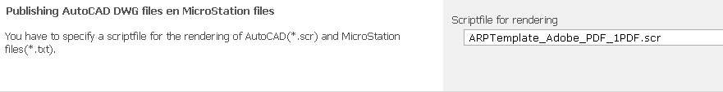

Note:
In the same Site the Workflow name must be unique per library.

Create Publish Office document
This documentation will show an example for publishing an Office document (*.xls;*.doc etc.).

- Open the correct SharePoint Site
- Select the correct SharePoint library
- Library Tools library Library Settings Workflow Settings Add a workflow
- Select a Workflow template: ‘Publish workflow’
- Type a unique name for this workflow: PublishCAD
- Select Next

Configuration:
- Trigger Workflow Settings options:
  - On a value of a specific metadata fields
  - When a minor version is created
  - Only when a major version is created

You can always start the workflow manually.

- Check ‘Convert the document’
- Define the target location, Publish library (Tip: copy & paste URL from Organice without ‘/Forms/AllItems.aspx’).

- Give a TAB to fill the mapped fields after entering the document library
- Set the file extension that should use this workflow: .doc;.docx;.xls;.xlsx
- The script is not relevant for Office conversion.

Note:
In the same Site the Workflow name must be unique per library.

Publish Credentials

Job server
The link between the Job server and the SharePoint server is made using an account that is configured on the Job server.

- On the job server open the program group ‘Organice Publish’ and start the program ‘Organice Publish Job Launcher Configuration’
- Monitored Servers And Credentials should contain the account that is able to read from a specific SharePoint location:
http://<Servername>/organicebatchadministration

Please check if the URL is available from the job server.
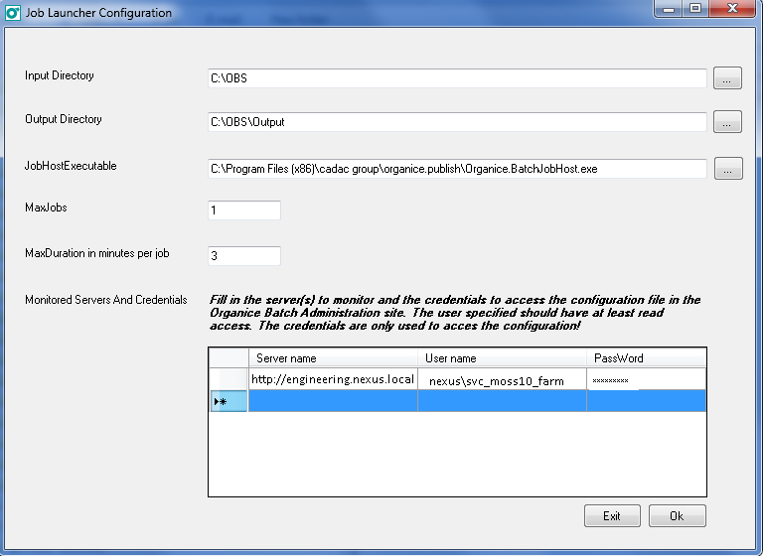

- Input Directory C:\OBS is the Job server hard disk location where the SharePoint documents are downloaded to.
- Output directory is the hard disk location the conversion (PDF) result is placed.

SharePoint server
The Publish process downloads and uploads documents. For these actions a user account is defined per server that needs to be accessed.

- To add the user account, please use the option on the ‘OraganiceBatchAdministration’ Site.
http:// <Servername>/organicebatchadministration

- Select option ‘Manage Server Credentials’
- Select ‘New Server’ (Top left)
- Enter the server URL
- Domain + Account name
The account must have the next security permissions:
  - Read permissions to download a file from the source location
  - Contribute permissions to upload a file to the target location
- Password

Result test environment:

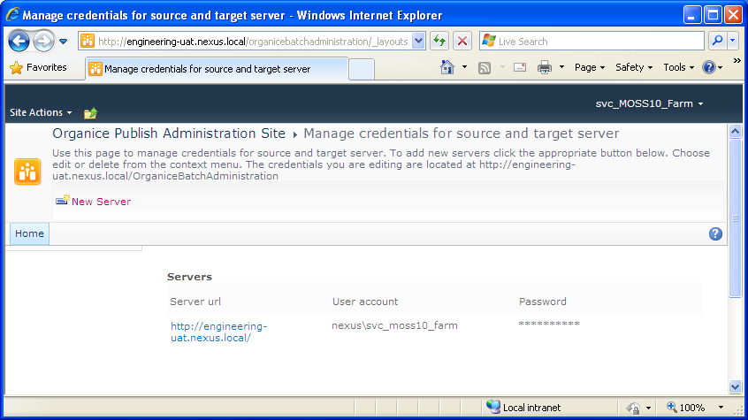

Job Server, Job Launcher
The job Launcher is located on the Job Server and downloads documents, which need to be published, from the Publish Queue.

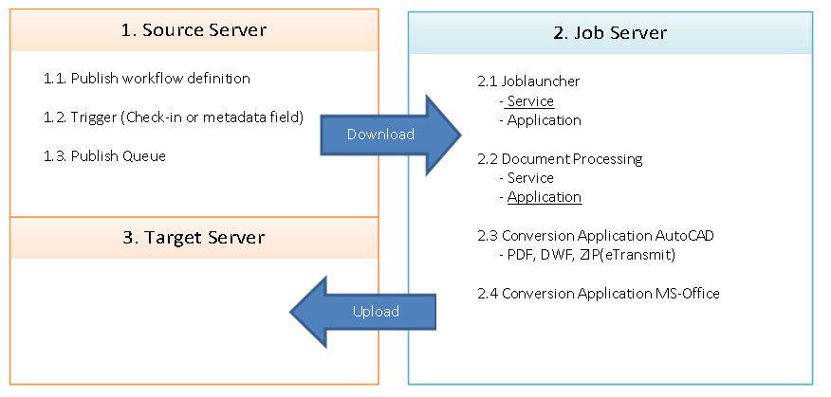
Picture 4 Job Launcher download and Upload

The publish queue is located in the ‘OrganiceBatchAdministration’ site.
http:// <Servername>/organicebatchadministration/OrganiceBatchQueue

The Job Launcher is located on the Job server and is available in two options.
Note: Only one should be active. Don’t use both at the same time.
- Organice Job Launcher Service
  - Preferred option.
  - The account attached to the Job Launcher service is the account the Job server is logged in with

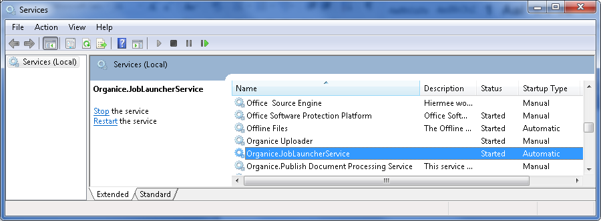

- Job Launcher application
Start this application from the windows start menu, Organice Publish, Organice Publish Job Launcher

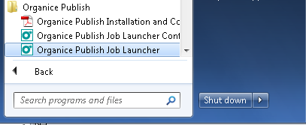

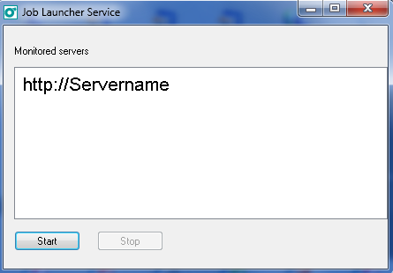

Job Server, Document Processing Service (DPS)
The Document Processing Service/Application is located on the Job Server and converts the downloaded document to the required format (PDF).

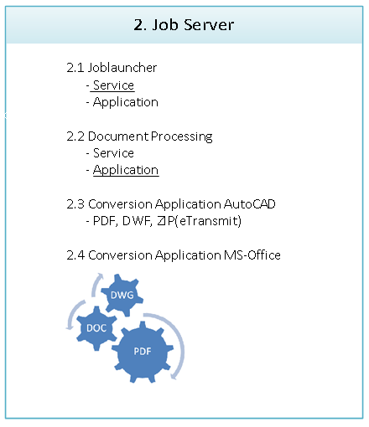
Picture 5 Document Processing

The Document Processing is located on the Job Server and is available in two options.
Note: Only one should be active. Don’t use both at the same time.
- Organice Publish Document Processing Service
  - Please attach a service account so that no password changes are required.
  - The account attached to the service is the account the Job server is logged in with

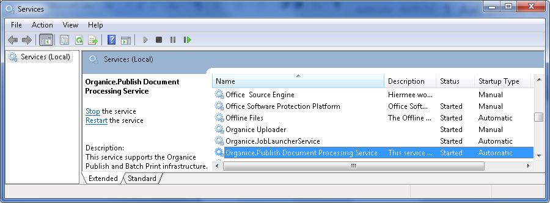

- Organice Publish Document Processing Application
This is the preferred option when a customer starts using Organice Publish. The advantage is that the AutoCAD application is visible during conversion which enables the user to track errors that may occur in the first phase of the implementation (learning phase).

Shortcut:
"C:\Program Files (x86)\Cadac Group\ Organice.Publish\DocProcService\Organice.Batch.OrganiceBatchjobService.exe" app
Start the application from the Job Server desktop.

Picture 6 Start Document Processing Application

The Document Processing queue is displayed in the next dialog box.

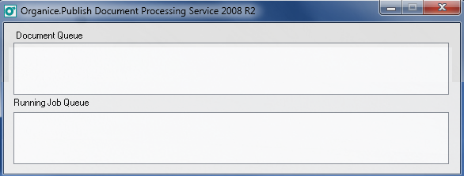
Picture 7 Document Processing Queue

Configuration
The Document Processing is dependent of several configuration files located on the job server.

- WindowsRenderingService.config
- Organice.Batch.OrganiceBatchjobService.exe.config
- ACADRenderingPlugin.config

For details we refer to the Publish standard documentation:

- Organice.Publish Document Processing Service Configuration Guide 2008 R2.pdf
- Organice.Publish DPS Configuration Guide 2008R2 Upd1.pdf

Debugging
Organice Publish is an application that is depending on several configuration settings and requirements to give a correct publish result. It can also be divided in several processes that are executed to get to the final result. Each process has its logging files that can be examined if a publish job fails. This document describes the points of interest during an unsuccessful publication. Let’s hope you will never need this chapter.

User: Workflow status indication per document
The publication of a document can be triggered in several ways depending on the Publish configuration. Because the Publish action is performed by a SharePoint workflow there is a field/column attached to the specific workflow showing the status.

This status field/column is an important indication for the user to see if the publish action was successful. Make sure that the field is present in at least one view or, if there are multiple Publish workflows present, create a separate view for the publish information.

The user has a certain responsibility to report or checks failed publish actions. This could also be a task for an application manager.

The status field of the publish workflow can have the next values (in this order):
- Waiting for publishing
- Publish started
- Published
- Failed

Publish Queue
The publish queue is located in the ‘OrganiceBatchAdministration’ site:
http://<servername>/organicebatchadministration/OrganiceBatchQueue

If the Jobstatus is ‘Failed’ or ‘Aborted’ instead of ‘Success’ it is possible to restart the publish process by editing this item in the publish queue and change the JobStatus field to ‘Waiting’. From Organice this can be done for a selection of items.

There can be several reasons for re-publishing:
- If you know what the reason for failure was, the document can be changed in the document library and republished directly from the queue. This is not necessary if a checkin of the document automatically starts the publish process.
- There was a technical failure (e.g. Publish location not accessible). Restart the publish action from the queue without changing the document.

It is also possible to give priority to files with the JobStatus ‘Waiting’ by changing the ‘JobPriority’ to ‘High’.

Smart Inspect
A part of the job server installation is the Smart Inspect logging tool. All actions of the Publish process can be tracked in this logging tool except the rendering (conversion) of the document.

Real-time:
If the client is running on the job server you can check the actions in the dialog box for the active publish job. The Smart Inspect client can be started from the desktop using this icon:
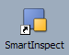

Publish steps
There are several ways to check why a publish action was not successful. Before we discuss these options it is important to divide the publishing process into a few critical steps:
Download
From source library
Rendering
AutoCAD
MS-Office
Upload
To target
library
- The job launcher service downloads
the SharePoint document to the Job server input folder.
For this service it is important that the account
that is used has the correct access rights to the
document Libraries.

- The Document Processing Service (DPS) starts
the attached application and renders (converts)
the document. E.g. AutoCAD is started and a script
is used to create a PDF file.

- The Job launcher service uploads the output document to
the SharePoint destination library.

The first action to determine the cause of a publish failure is to detect in what step the failure occurs.

Step 1 and step 3
Failures in Step 1 and step 3 can be detected by the logging tool Smart Inspect that is part of Organice Publish installation on the Job Server,

Step 2
Failures in step 2 can be detected by looking at the AutoCAD log files.

Freeze logging information
While looking at the Smart Inspect logging information the logging will continue to scroll because other publish actions are still running. To prevent this from happening click the ‘Save’ button (CTRL+S) and create a temporary log file. Open this file by double clicking. A separate Smart Inspect dialog box will open where you can examine the log information. This log file only contains the information until the save moment.

Search logging information / track a document
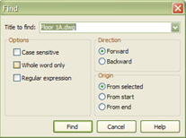
Smart Inspect offers search functionality.
Pulldown menu Navigate, option Find (CTRL+F)

If you enter the name of a drawing number you can go directly to the logging of a specific file.

The next log entries are specific markers in a successful publish job for a search on drawing number VW252-02-0500.

PublishJob started for url http://wss3-dc/sites/03552/doclib1/VW252-02-0500.dwg workflow Publish_DWGto1DWF

Downloading http://wss3-dc/sites/03552/doclib1/VW252-02-0500.dwg

DownloadFile: http://wss3-dc/sites/03552/doclib1/VW252-02-0500.dwg

File is downloaded correctly to the following directory c:\obs\job633407872\http\wss3-dc\80\sites\03552\doclib1\VW252-02-0500.dwg

Relative path of downloaded document is : job633407872\http\wss3-dc\80\sites\03552\doclib1\VW252-02-0500.dwg

Uploading c:\obs\output\VW252-02-0500.DWF to targetUri http://wss3-dc/publish/03552/doclib1/VW252-02-0500.DWF

Creating document link for source http://wss3-dc/sites/03552/doclib1/VW252-02-0500.dwg to target http://wss3-dc/publish/03552/doclib1/VW252-02-0500.DWF

Document http://wss3-dc/sites/03552/doclib1/VW252-02-0500.dwg is published to http://wss3-dc/publish/03552/doclib1/VW252-02-0500.DWF

Job exited with status: Success

AutoCAD log
If you want to check the actions in AutoCAD use the AutoCAD log. This is the best way to check why a document is not rendered correctly. To activate the AutoCAD log and to define a specific location, please make the following settings.

- Start AutoCAD on the job server. Make sure you logged in (in windows) with the same account running the Publish services.
- On the AutoCAD command prompt type: options
- Select the tab “Open and Save” ( see picture)
- Selected the option ‘Maintain a log file’.
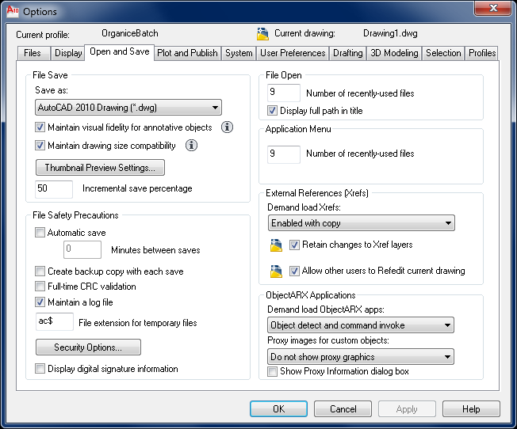

- Select the tab “Files” ( see picture)
- Select the option “Log Files Location” and define the folder for the log file.

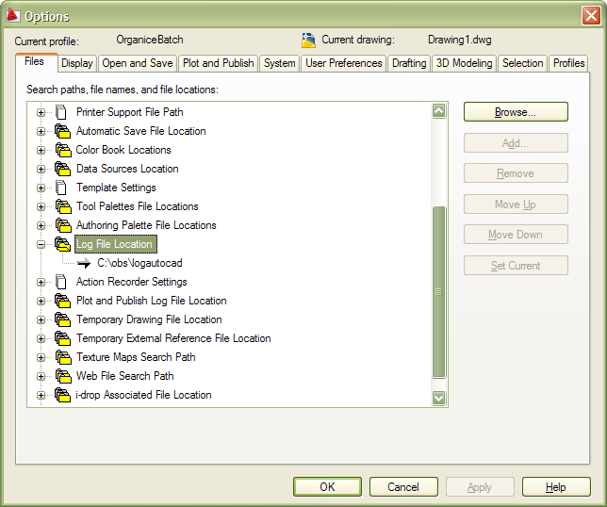

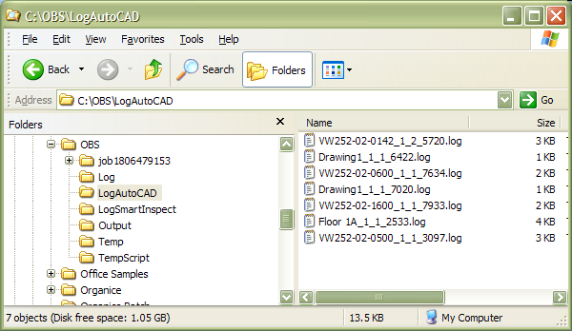

All AutoCAD prompts including the action that are performed by the script file will be visible in a log file with the same name (prefix) as the drawing.

Note:
The log files are not deleted automatically. This needs some maintenance.

